**Team Deliverable 4 – CSCE 5430 Software Engineering**

**A. Requirements**

## **Item Posting**

Users who have items to sell or give out for free will post the items on the systems for those in need to buy or collect the item(s) for free.

* + 1. The system shall allow users to post items by requesting the category of the item, the name of the item, a description of the item and a picture of the item being posted. The maximum size of a picture shall be 1MB.
    2. The system shall record the date and time of posting the item.
    3. The system shall also allow a user to specify the number of items available to post. The default value will be one.
    4. The system shall request the user to select the way he/she wishes to deliver the item to the buyer. Options shall include “Collect from seller”, “Deliver to buyer” and “Buyer will be contacted upon purchase”.
    5. The system shall generate a success message to inform the user of a successful post.
    6. After successfully posting, the system shall make the item available for search and display on the website.
    7. The system shall allow a user to edit a post from his/her profile after a successful post.

## **3.4 Item Search**

The system shall provide a search option on the website, where users will be able to search for items according to their need. Both users and website visitors will have access to the search option. However, as mentioned before, item posting, and buying are reserved only to registered users.

* + 1. The search box shall be located on required pages at the banner.
    2. The search box will accept text from users and return results containing the best matches.

## **3.5 Item Buying**

Items posted by users on the website can either be bought or collected for free as per the specification given by the poster.

* + 1. The system shall allow users to browse items by category.
    2. The system shall allow users to select items of interest and add them to their shopping cart.
    3. The systems permit users to select multiple items posted by different buyers and add to the shopping cart
    4. After adding items of interest to the shopping cart, the user will checkout the items.
    5. Upon successful check out, the system will post those transactions to the respective sellers, who will be able to access them by logging into their account.
    6. The system shall record the time and date at which the user checked out.
* Almost all the requirements for this phase have been met, except the features described in 3.5.2 and 3.5.3 will have a full-fledged implementation in the next phase which has shopping cart feature as its requirements and a shopping cart is required to implement Item buying.
* All the other features and requirements specified in this phase where satisfied, including the criticalities that we mentioned in the deliverable 2.

**Updated Plan**: We will include the unimplemented parts in the phase 3 of our release.

**Phase 3:**

The phase 3 of the project will be focused on development of the features 3.5.2, 3.5.3, 3.6 and 3.7. By the end of this phase we plan on developing a full-fledged application that is ready to use by implementing the final features and testing them accordingly.

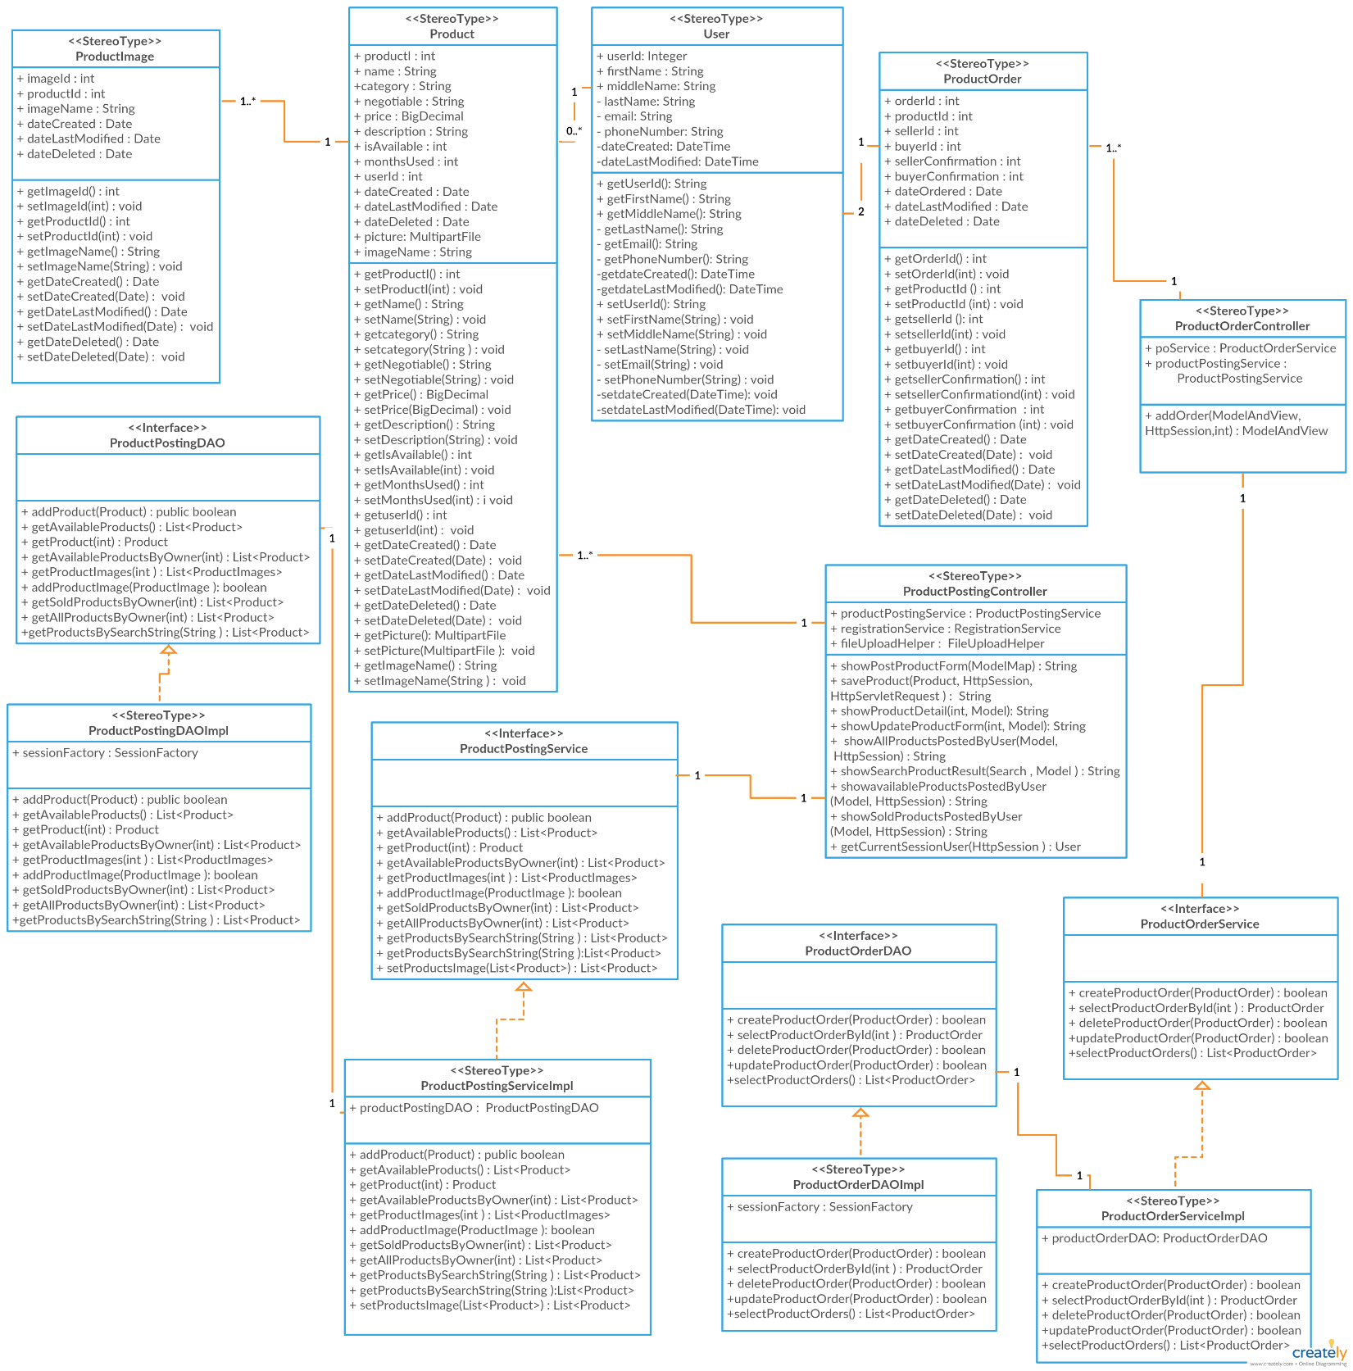**B. UML Diagrams**

1. **Class Diagram**

Figure 1: Class Diagram for Phase 2 (Created on Creately.com)

1. 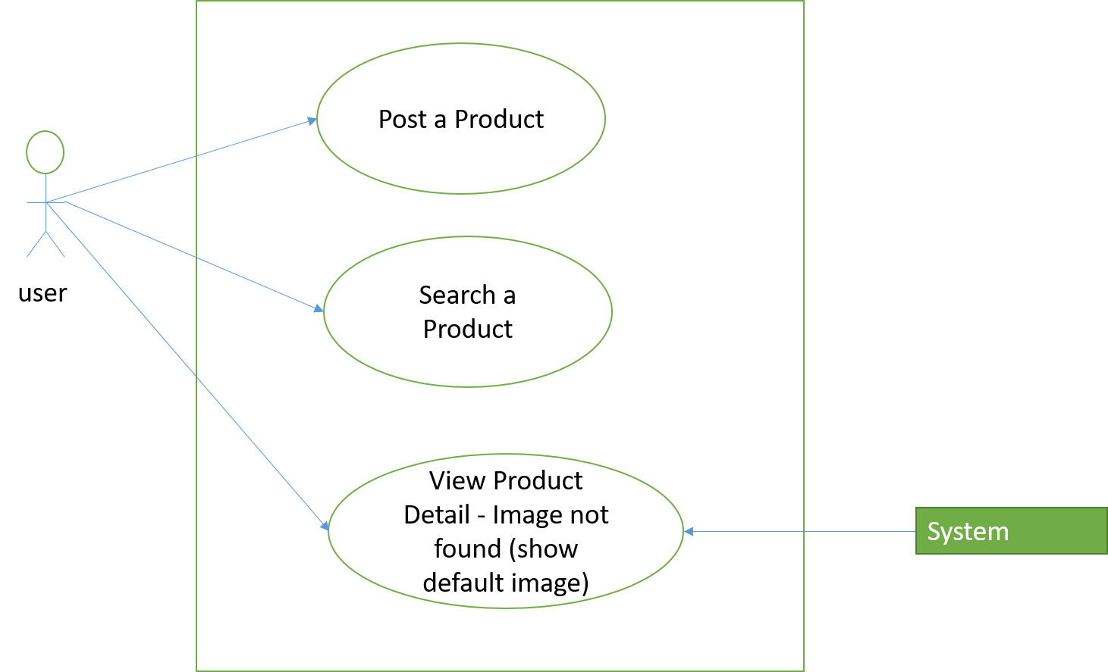**Use Case Diagram**

Figure 2: Use Case Diagram Phase 2

1. **Post a Product**

Main Success Scenario

1. User successfully Logs into the system (Use Case III in Deliverable 3)
2. User clicks on Post a Product Button
3. Post Product Form is displayed
4. User enters product details and optionally selects a picture for the product
5. User submits the Form
6. Form data is processed by the system
7. Submission is received and user taken to home page and added product is displayed

Extension

1a) User is not logged into the system. Post Product Button hidden for this user

4a) User does not enter product details. Clicking on submit button remains on the same page

6a) processing fails because of invalid form fields

6b) User is returned to post product form with error message

1. **Search a Product**

Main Success Scenario

1. User enters search string in search box
2. User clicks on search button
3. System queries the database of products
4. Products with matches are returned in a list

Extension

1a) user does not enter text in search box. Clicking the search button has no effect

3a) System does not find any match

3b) a no result found message is displayed to user

1. **View Product Detail – Image not found (Show default image)**

Main Success Scenario

1. User clicks on a product to view details
2. Systems retrieves product but image is not found
3. System attaches a default image to the product
4. Product details is displayed on new page with default image

Extension

3a) Default image is not found. An alternative text (product name) is displayed

1. **Sequence Diagram**
2. 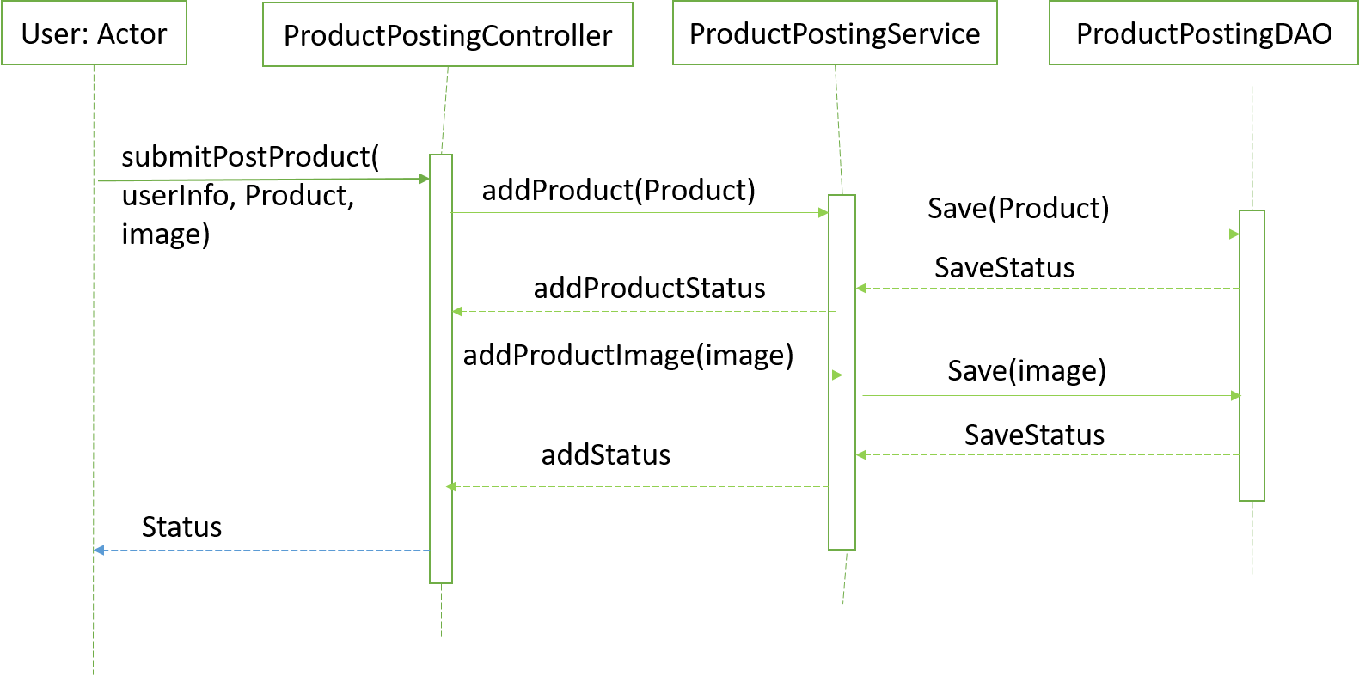Post A product

Figure 3: Sequence Diagram for Post a product use case

1. View Product Detail – Image Not found (Show Default Image) – Error Use Case

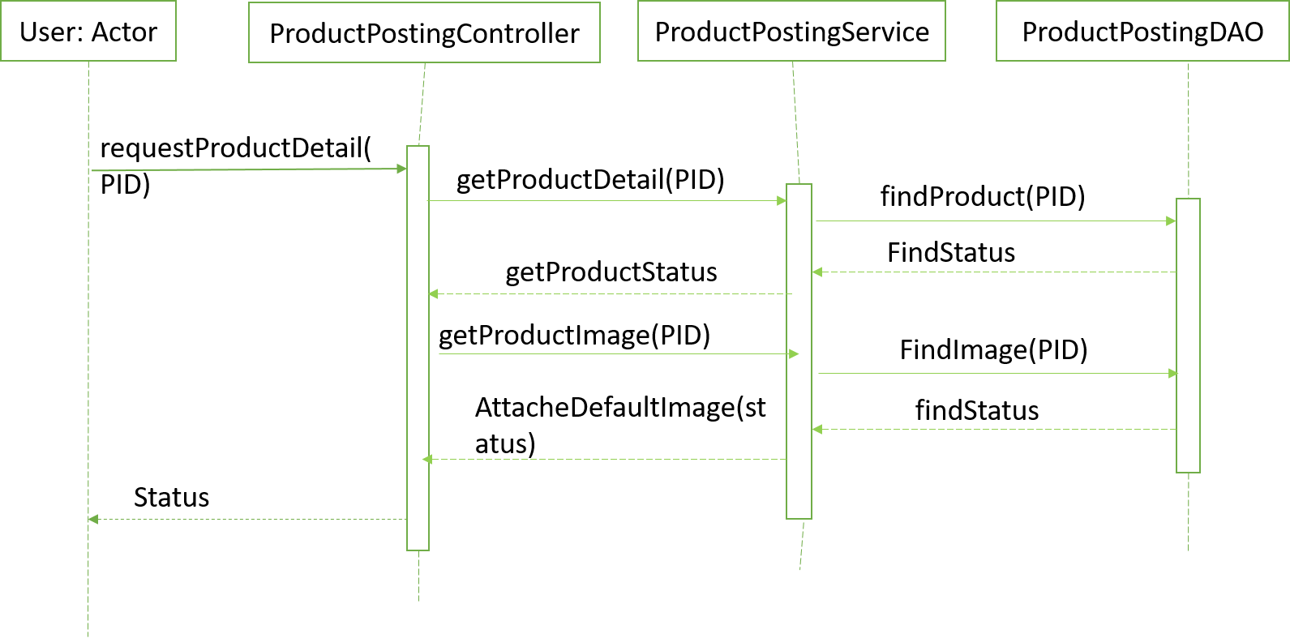

Figure 4: Sequence diagram for Error case View product Detail - Image Not found (show default image)

**C. Test Cases:**

|  |  |  |  |  |  |  |  |  |  |
| --- | --- | --- | --- | --- | --- | --- | --- | --- | --- |
| **Project Name** | | studentsurplus | | **Module Name** | | | | ProductPosting | |
| **Created By** | Haidi Chen | **Created Date** | 11/11/2018 | **Tested By** | | Haidi Chen | | **Tested Date** | 11/12/2018 |
| **Test Scenario 4 – Verify the Functionality of Home Page** | | | | | | | | | | |
| **Test Case ID** | **Test Case Description** | **Test Steps** | **Preconditions** | | **Test Input** | | **Expected Output** | **Actual Output** | **Status** |
| 12 | hit “home” icon | 1. Click on the “home” icon | Valid URL, | | N/A | | home page | home page | pass |
| 13 | hit “Sell” component | 1. Click on the “Sell” icon | Valid URL, | | N/A | | product posting page | product posting page | pass |
| 14 | hit “My products” component | 1. Click on the “My Products” icon | Valid URL, | | N/A | | My products page | My products page | pass |
| 15 | hit “Login/Register” component | 1. Click on the “Login/Register” icon | Valid URL, | | N/A | | login page | login page | pass |
| 16 | search specific products via search bar | 1. Type in the search bar 2. Click on the “Search” icon | Valid URL,  Test Data | | type “iphone” in search bar | | product list page | Displays search results | pass |
| 17 | navigate the picture zone | 1. Click on the arrow left or right | Valid URL | | N/A | | show next or previous picture | next/previous picture | pass |
| 18 | edit user profile | 1. Click on the “user” icon to get a dropdown list 2. Click on the “edit profile” label | Valid URL | | N/A | | profile editing page | profile editing page | pass |
| 19 | logout function | 1. Click on the “User” icon to get a dropdown list 2. Click on the “Logout” label | Valid URL | | N/A | | login page | login page | pass |
| 20 | show products owned by user | 1. Click on the “User” icon to get a dropdown list 2. Click on the “My Products” label | Valid URL | | N/A | | My products page | Shows products sold by the user | pass |
| 21 | view details of product posted on home page | 1. Click on product label “View Details” | Valid URL | | N/A | | product details page | No Response (yet to be implemented) | fail |
| **Test Scenario 5 – Verify the Functionality of Product Posting Page** | | | | | | | | | | |
| **Test Case ID** | **Test Case Description** | **Test Steps** | **Preconditions** | | **Test Input** | | **Expected Output** | **Actual Output** | **Status** |
| 22 | enter valid information for all fields | 1. Fill in the fields 2. Click on the “Submit” button | Valid URL,  Test Data | | Name = chair  Category = Furniture  Months Used = 4  Price = 40  Negotiable = yes  Description = a perfect second-hand chair  img = xxx | | home page with new product just posted | home page with new posted product | pass |
| 23 | enter valid information in fields except for the field “Months Used” | 1. Fill in the fields except “Months Used” with valid input 2. Fill in the field “Month Used” with string instead of integer 3. Click on the “Submit” button | Valid URL  Test Data | | Name = mattress  Category = Furniture  Months Used = test  Price = 30  Negotiable = yes  Description = a second-hand mattress  img = xxx | | show error message and stay at current page | Alert error pop up | fail |
| 24 | enter nothing in the fields and submit | 1. Click on the “Submit” button directly | Valid URL  Test Data | | all fields left as blank | | show error message and stay at current page | Error pops up | pass |
| **Test Scenario 6 – Verify the Functionality of My Products Page** | | | | | | | | | | |
| **Test Case ID** | **Test Case Description** | **Test Steps** | **Preconditions** | | **Test Input** | | **Expected Output** | **Actual Output** | **Status** |
| 25 | delete the product | 1. Click on the “delete” button | Valid URL | | N/A | | refresh current page without the product which is deleted | No response  (yet to be implemented) | fail |
| 26 | edit the product | 1. Click on the “Edit” button | Valid URL | | N/A | | product editing/posting page | product editing/posting page | pass |

Table 1: Test Cases for Phase 2

**The path of test case implementation:**

* SourceCode\unt.cse.studentsurplus\src\test\java\unt\cse\studentsurplus\controller\ProductPostingControllerTest.java
* SourceCode\unt.cse.studentsurplus\src\test\java\unt\cse\studentsurplus\controller\ProductOrderControllerTest.java
* SourceCode\unt.cse.studentsurplus\src\test\java\unt\cse\studentsurplus\service\**ProductPostingServiceImpTest.java**
* SourceCode\unt.cse.studentsurplus\src\test\java\unt\cse\studentsurplus\service\ProductOrder**ServiceImpTest.java**

**D. Components:**

|  |  |
| --- | --- |
| **Components** | **Developed By** |
| Front End Pages for posting a product and home page for displaying posted products. | Sri Sravya Tirupachur Comerica |
| Back –End Implementation for Posting a product and search. | Aboubakar Mountapmbeme |
| Unit test cases and product order module. | Haidi Chen |
| Front page for user to view his/her products. | Amisha Gadhia |

**E. User Manual:**

**Login:**

* By clicking on the register here link on the page, the user will be redirected to the registration page.
* If already registered, he can simply login using his username and password. [1]

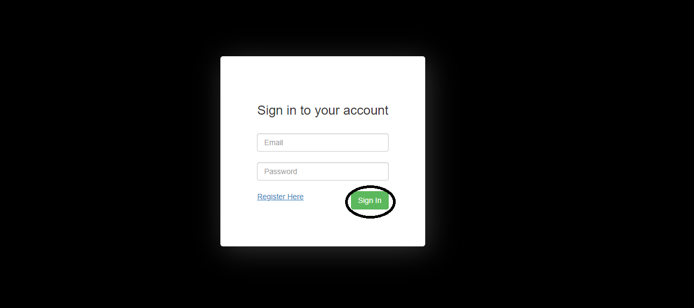

Picture (i) Login Page

**Registration:**

* A user can register by filling in the fields that are provided below.
* By clicking on the submit button given below, the user will be successfully registered. [1]

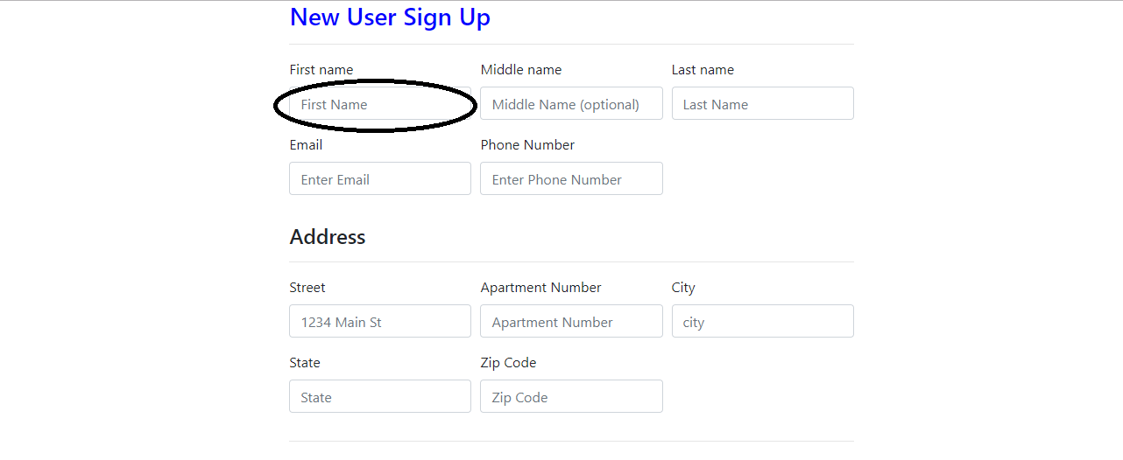



Picture (ii) Registration Page

**My Profile:**

* This user profile page will show the details of the user and they can also change their details by clicking on the edit button. [1]

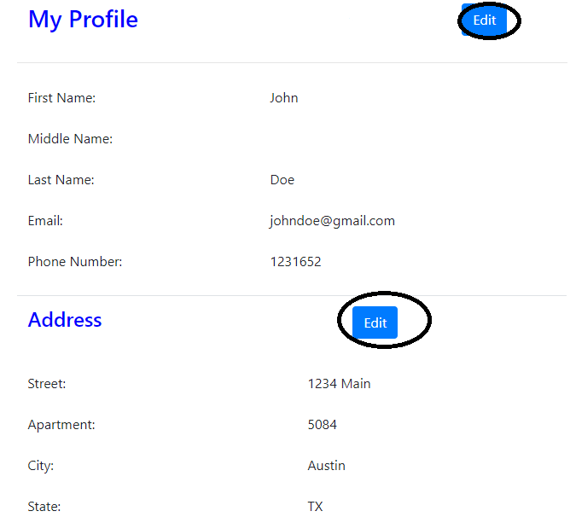

Picture (iii) Profile Info Page

**Profile update:**

* After clicking the edit button the user will see fields where he can manually edit his details
* Clicking on the submit button will change the user details and display it to him on the user profile page. [1]

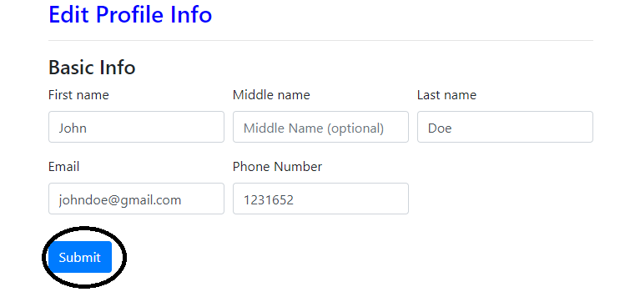

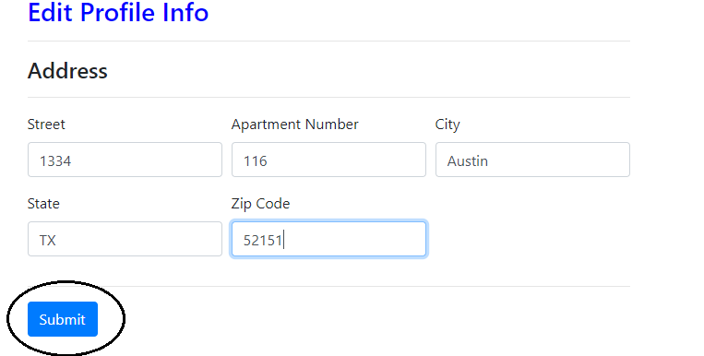

Picture (iv) Profile Update Page

**Home Page:**

* Home will provide options for the user to sell, view his products, edit his profile and also to logout of his account.
* **Sell**: By clicking on sell on navigation bar the user will be redirected to a page where he can post the products.
* **My Products**: By clicking on sell on navigation bar the user will be redirected to a page where he can view the products posted by him.
* **User Name**: By clicking on the user name on navigation the user will see a dropdown where he can edit his profile and logout of his account.
* **Home**: By clicking the on the user can return back to home page. [1]

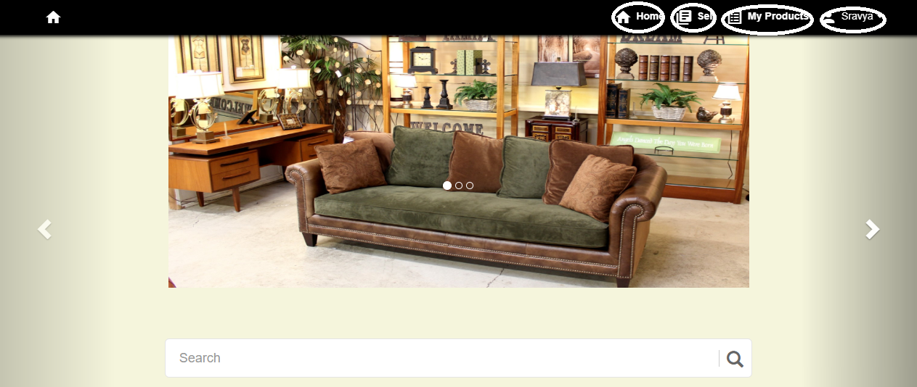

Picture (v) Home Page

**Post a Product Page:**

* This page has the features where a user can post a product through the provided interface, he will have to fill in the details such as name, category, months used, negotiable and its description. [1]

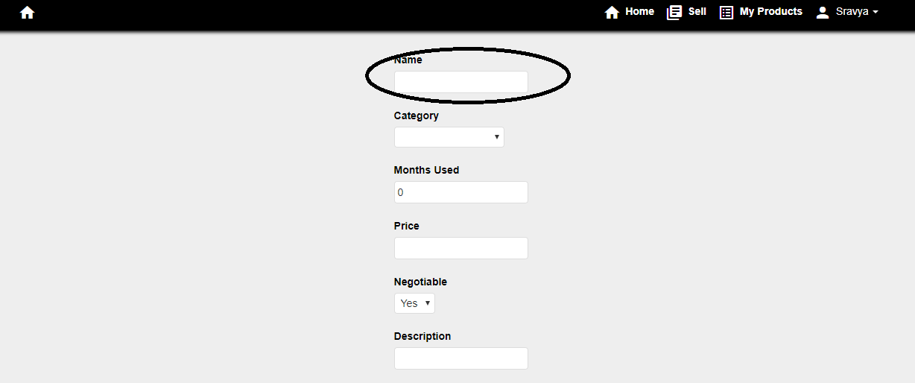

Picture (vi) Post Product Page

* The user will be given an option to upload the image, by clicking on the Add Image button as shown below.

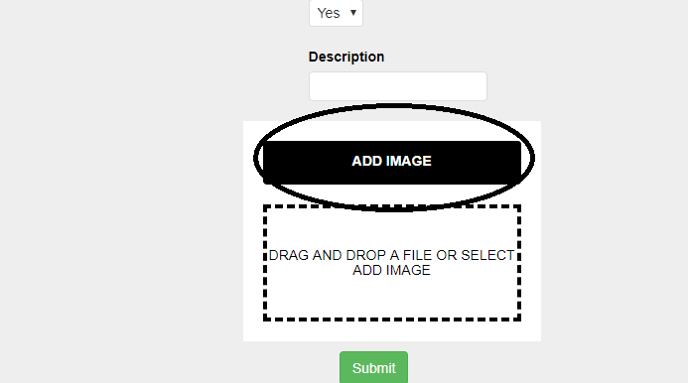

Picture (vii) Add Image Feature

* The user will also be shown a preview of the image and a feature to remove the image by clicking on remove image icon as shown below.
* Finally, by clicking on the submit button his product will be posted in the website and will appear on the home page.

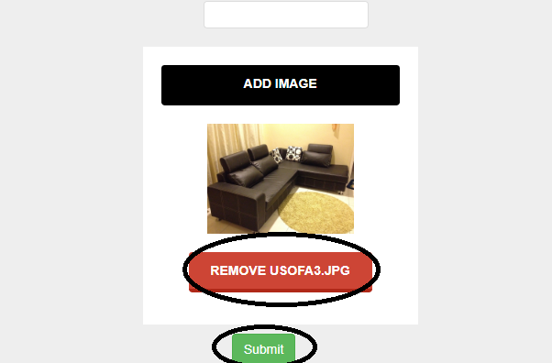

Picture (vii) Remove uploaded image feature

**Search Feature:**

* The search feature, enables a user to search an image based on the category or keywords the provided in the description. And the page will return the results matching the search keyword. [1]

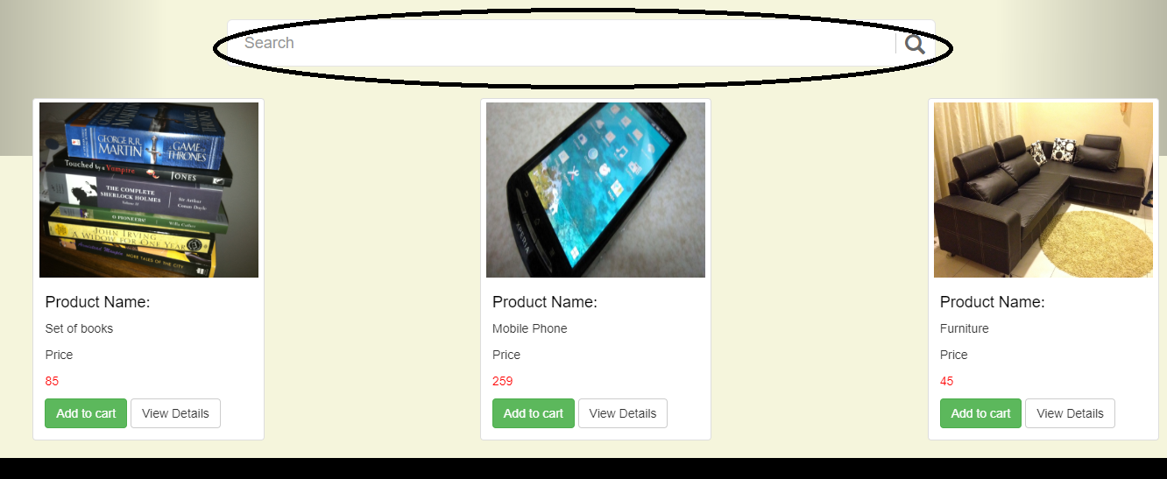

Picture (vii) Search Feature

**View My Products Feature:**

* 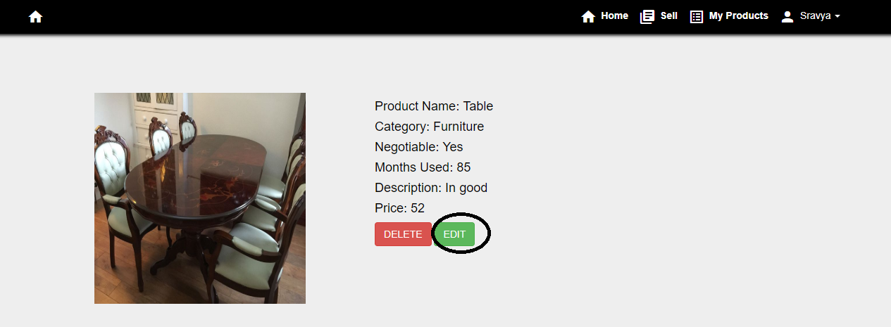By clicking on my products page on the navigation bar the user will be redirected to my products page, wherein he can view and edit products posted by him/her

Picture (viii) Edit Feature

**F. Instructions on how to compile and run:**

Software Required: Tomcat Server 9, MySql Database and Eclipse IDE.

* Program:

1. Open the project file in Eclipse IDE.
2. Open MySql.
3. Open the studentsurplus.xml file and set the data source values of username and password to your local database’s username and password.
4. unt.cse.studentsurplus-> run as-> Maven Build
5. unt.cse.studentsurplus->run as-> run on server

* Test Cases

1. unt.cse.studentsurplus->src/test/java-> ProductPostingControllerTest.java
2. RegistrationControllerTest.java-> run as-> JUnit Test

**References:**

1. https://www.bridgemaneducation.com/documents/how-to-guide.pdf

Group Name: **DASH**

Project: **Student Surplus**